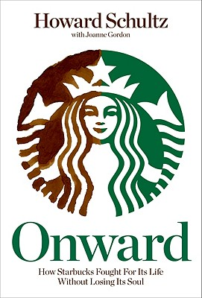What is *Onward?*

*“In 2008, Howard Schultz returned as the CEO of Starbucks to help restore the company's financial health and refocus on its core values. In Onward, he shares the story of the company's turnaround, revealing how, during one of the most tumultuous economic periods in American history, Starbucks once again achieved profitability without sacrificing humanity.”  
 -from Starbucks.com*

***“Were not in the business of filling bellies; we’re in the business of filling souls”***

*-*Howard Schultz, chairman of Starbucks Coffee

**What *is* the secret to Starbucks Profitability?**

* The company pays poverty wages and has slashed benefits for employees and forced them to contribute more to their health plans
* Starbucks has introduced scheduling rules on employees forcing them to be available 80 hours per week, but still refusing to guarantee even part time hours for employees
* Starbucks insures fewer employees than the notoriously low wage, Wal-Mart
* Starbucks continually understaffs its stores while demanding that employees adhere to the three minute rule of getting guests in and out of their store in three minutes or under.
* Since 2004 Starbucks has waged a ruthless union busting campaign against the Industrial Workers of the World Starbuck Workers Union which has included illegally targeting, and firing union organizers and sympathizers at stores across the US and in Spain

**What are These “Core Values?”**

  
Despite Howard Schultz’s talk of filling souls and not sacrificing humanity in his pursuit of dominance and profitability it is clear that he has built Starbucks and his own wealth on the backs of Starbucks’ employees. Despite forcing hourly employees to absorb the brunt of the recession and sacrifice hours, stability and benefits, Schultz has been handsomely rewarded.

Did you know Schultz’s 2009 income of $14,971,152 is 836 times greater than the salary of an average Starbucks employee ($17,901)? Does he really work 836 times more than the average employee?[1]

Is this his way of not sacrificing humanity in pursuit of profitability? Why is Schultz doing so well while his employees continue to struggle to make ends meet? Why does he continue paying millions of dollars to union busting law firms while asking for greater sacrifice from his employees? We’re sure he does want to move “onward” from these questions? We think he needs to be held accountable.

**We demand that Schultz move “onward” from throwing his employees under the bus in the name of profitability and from illegally firing them for engaging in legally protected union activity. Most of all Starbucks employees and the IWW Starbucks Workers Union are demanding RESPECT on the job! Howard maybe you should focus on filling your employees bellies rather than your own pockets!**

**For more information about the Starbucks Workers Union visit: http://www.starbucksunion.org**

1. This information was collected from http://seattletimes.nwsource.com/html/businesstechnology/2012136200_ceotopfive20.html and http://www.glassdoor.com/Hourly-Pay/Starbucks-Barista-Hourly-Pay-E2202_D_KO10,17.htm   
    IWW labor donated