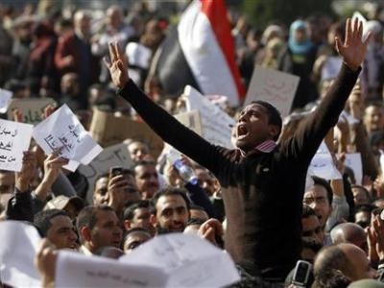 | Arab  Spring
Libyan Winter | 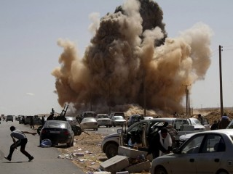

As millions of people across the Middle East and North Africa fight for freedom against tyrannical regimes, US warplanes bomb Libya with the stated aim of protecting civilians. But what are the real aims of the government's intervention? How do they relate to its wars and other policies in the Middle East? And what can those of us inspired by the democratic uprisings do to help?

At 7 pm on Thursday, July 7, Boston UNAC is bringing speaker, educator and Counterpunch contributor Vijay Prashad to speak to these questions. Dr. Prashad is professor and director of international studies at Trinity College, the author most recently of The Darker Nations: A People's History of the Third World (winner of the Muzaffar Ahmed Book Prize for 2009), and the forthcoming co-edited collection Dispatches from Pakistan. He is soon to publish (in early 2012) The Poorer Nations: A Possible History of the Global South. A $5 donation is encouraged but all are welcome.

July 7th · 7:00 pm · Encuentro 5

33 Harrison Ave. · 5th Floor · Boston
United National Antiwar Committee / Boston
BostonUNAC.org | bostonunac@gmail.com
(781) 285-8622 |  United National Antiwar Committee of Boston (UNAC-Boston)

