Support Encuentro 5!
3pm Sunday, July 1
5th floor, 33 Harrison Ave. (Orange MBTA Line to Chinatown, 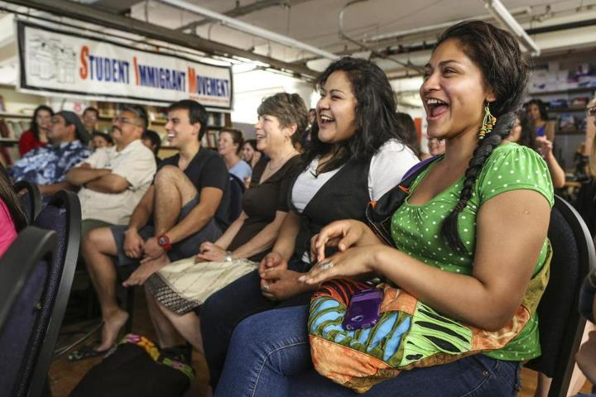or Red to South Station)
Encuentro 5 is a collective, community, and social-justice oriented space that benefits all of us. Recently, e5 has being asked to leave the space it has occupied for 6 years!
We are calling on all 20 resident e5 organizations, the 80 other projects and groups, and the whole progressive movement of Greater Boston to meet this Sunday, July 1 at 3pm to discuss what e5 means to us and we can do to support e5.
This will a public, open forum where a presentation by Suren Moodliar about the situation at e5 will be followed by a broad collective discussion and documenting of testimonials from activists, e5 resident organizations, and community members too.
Spread the word!
Facebook Event: https://www.facebook.com/events/384661094928966/

