The Latino Vote 2012
A Conversation with Oscar Chacón
Fundraiser for AFSC’s Project Voice
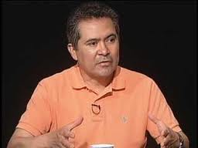
Oscar Chacon serves currently as Executive Director of the National Alliance of Latin American & Caribbean Communities (NALACC). Until December 2006, Mr. Chacon served as director of Enlaces América, a project of the Chicago-based Heartland Alliance for Human Needs and Human Rights. Mr. Chacón served for most of the 1990’s as executive director of Centro Presente in Massachusetts.

Thursday September 20th 6:00 PM
City Year Civic Room, 287 Columbus Av. Back Bay
Donation: $25

The November elections may well be the most important presidential contest in U.S. history. The coveted "Latino Vote" is in play, and will be consequential to the outcome of these elections. How has the Latino community faired under the first term of the Obama Administration? How would we fair under a Romney Administration? Will Prosecutorial Discretion and Deferred Action satisfy the Latino Voter? How will the Supreme Court decision on Arizona's SB 1070 affect other states' efforts to enact anti-immigrant laws? With the current economic crisis is Comprehensive Immigration Reform and the DREAM Act dead? What about democracy in Latin America?

,

For more information and tickets contact AFSC’s Project Voice director Gabriel Camacho at (617) 947-7019, or gcamacho@afsc.org
AFSC is a union shop: UNITE HERE Local 66L

