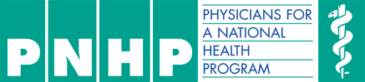

## AGENDA

* 5:00pm Doors Open, Start the Silent Auction, Cash Bar Opens
* 6:00pm Hors D’oeuvres Served
* 6:25pm Welcoming remarks from MassCare & PNHP
* Guest Speakers (10min speaking followed by 10min of Questions and Answers for each speaker)
  + 6:30 – 6:50pm Dr. Arnold Relman
  + 6:50 – 7:10pm Noam Chomsky
  + 7:10 – 7:30pm John Auerbach
  + 7:30 – 8:00pm Steven Tolman
  + 8:00 – 8:05pm Thank you from MassCare and results of the winners of the silent auction
* The Silent Auction will end at 8pm. Thank you to our generous donations from:
  + The Boston Red Sox
  + Grand Ten Distilling
  + Samuel Adams
  + The New England Revolution
  + Gourmet Gift Baskets.com
  + The Top of the Hub
  + Mass MoCA

# C:\Users\Benjamin Day\Desktop\invitewithnewnames.jpg

### October 30th, 2013

### 5:00pm – 8:00pm

### UMass Club, 225 Franklin Street, Boston, MA. 02110